# Interfacing & Writing driver for a SCCB Interface Camera, OV7670 with Arduino

Part 1:

OV7670 is an OMNI Vision camera CMOS VGA, Camera chip sensor that we have here, the OV7670/OV7171 provides full-frame, sub-sampled or windowed 8-bit images in a wide range of formats like YUV/RAW, and is controlled through the Serial Camera Control Bus(SCCB) Interface...It has an image array capable of operating at up to 30 fps/Night Vision in VGA with complete user control over image quality, formatting & output data transfer. All required image processing functions, like exposure control, gain, gamma, white balance, color saturation, hue control and more, are also programmable through the SCCB Interface to the Camera sensor registers...In addition, OmniVision sensors use proprietary sensor tech to improve image quality by reducing or eliminating common lighting/electrical sources of image contamination, such as fixed pattern noise(FPN), smearing, blooming, etc. to produce clean, fully stable color images. This Camera Sensor, OV7670 comes with a FIFO Memory Buffer, AL422B.

Now, the FIFO Memory Buffer Chip, AL422B captures the video image data from the main camera chip and we Read the Image Data from the FIFO. The Camera Clock generator creates a Clock Pulse that drives the XCLK Input of the Main Camera Chip. The Video Port output of the main Camera chip pins D0-D7 are connected with the Video Frame Buffer FIFO, AL422B Memory's input Data Pins which are D10-D17.

The PCLK on the Main Camera camera chip that is synced with the output of Bytes that represent the pixels of the Image is connected to the FIFO memory's WCK that is synced with writing of this pixel data to the memory. The HREF output pin on the Main Camera chip is connected to a NAND Gate with a user input Write Enable  signal that will activate writing data to the FIFO memory when the Write Enable signal is HIGH and the HREF is HIGH. This results in a HIGH Value from the AND operation and a LOW Value from the NOT operation which activates the /WE input to the FIFO Memory which is active LOW. The NAND Gate is the Key to Writing image Data to memory.

Please see the overall schematic carefully, as earmarked

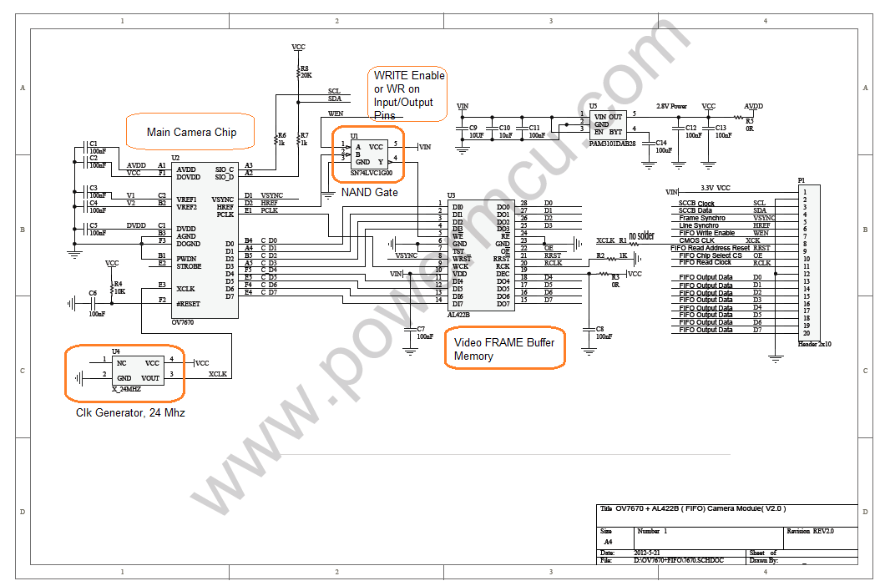

The Main Camera Chip outputs a single Video Frame image through the 8-Bit Video Port by:

      >   Pulsing VSYNC High to indicate start of a New video frame for output.

      >   The HREF goes HIGH when a Valid row of Pixels from the Video Frame is put on the output Video Port pins of D0-D7. This continues for each Row from Row 0 to the Last Row for the Image size which is Row 479 for a VGA Screen resolution (640 x 480). In addition, when the HREF is HIGH, the PCLK syncs with the output of the Bytes for each Row in the Image. See the fig. below:

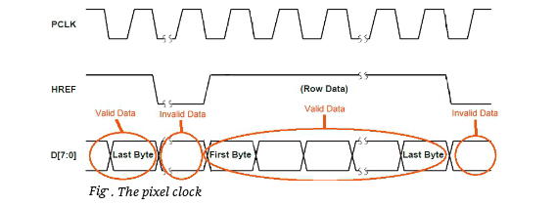

  >   The VSYNC Pulses HIGH again to indicate the end of the Video Frame Output. See Fig. below for the simplified Timing Diagram:

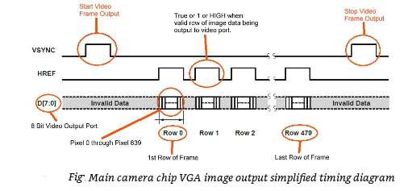

The Image output from the Main camera chip is then fed into the FIFO Video Frame buffer memory. From there it is READ by the Arduino. The general operation of the Frame Buffer is given by the functional block diagram as given below:

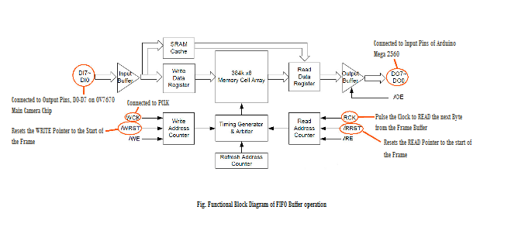

In order to capture a Video Frame being output by the Main Camera chip we need to:

1. Wait for the VSYSNC to pulse to indicate the start of the Frame.

2. Reset WRITE Pointer to 0 which is the beginning of the Frame.

3. Set FIFO WRITE Enable to Active(High), so that Image can be written to the RAM.

4. Wait for VSYNC to Pulse again to indicate the end of the Frame capture.

5. Set FIFO Write Enable to LOW, so that no more Images can be written to the RAM.

In order to READ the Video Frame that was captured into the FIFO Memory you need

to:

1. Set the FIFO READ Buffer pointer to Start of the Frame.

2. For every Byte of Data in the Image, Pulse the READ Clk, RCK to bring in a New Byte of Data onto the Video Output Port and then READ it into the Arduino.

Once, we have the Byte of Image Data into the Arduino's memory, we can process this Data by writing it to a SD Card.

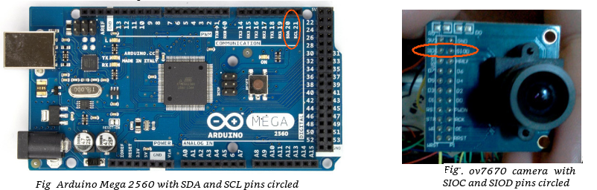

And my setup,

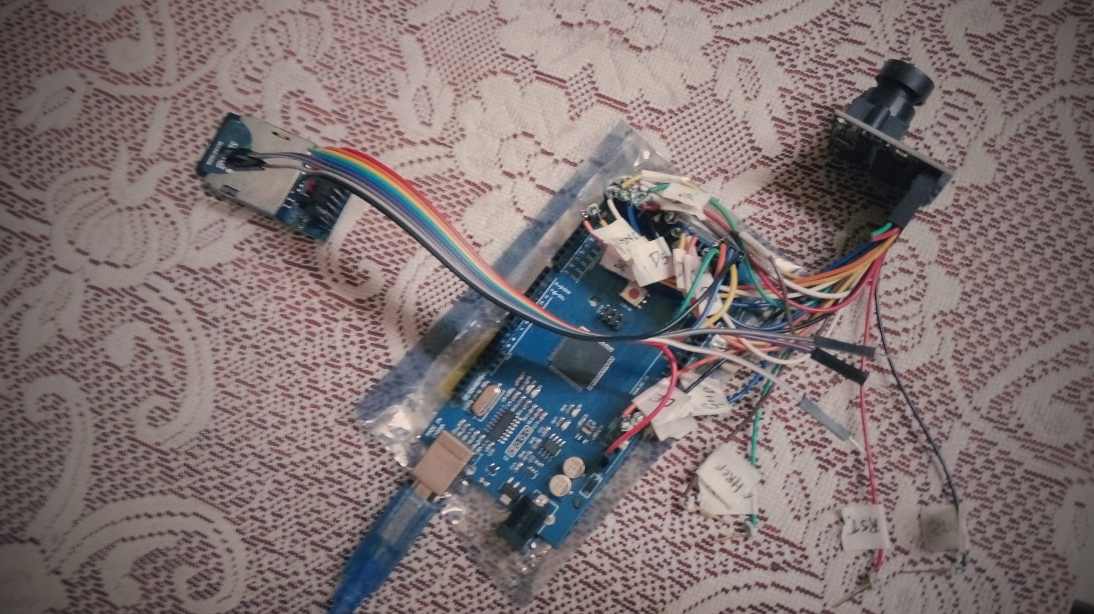

My OV7670 Driver in Execution,

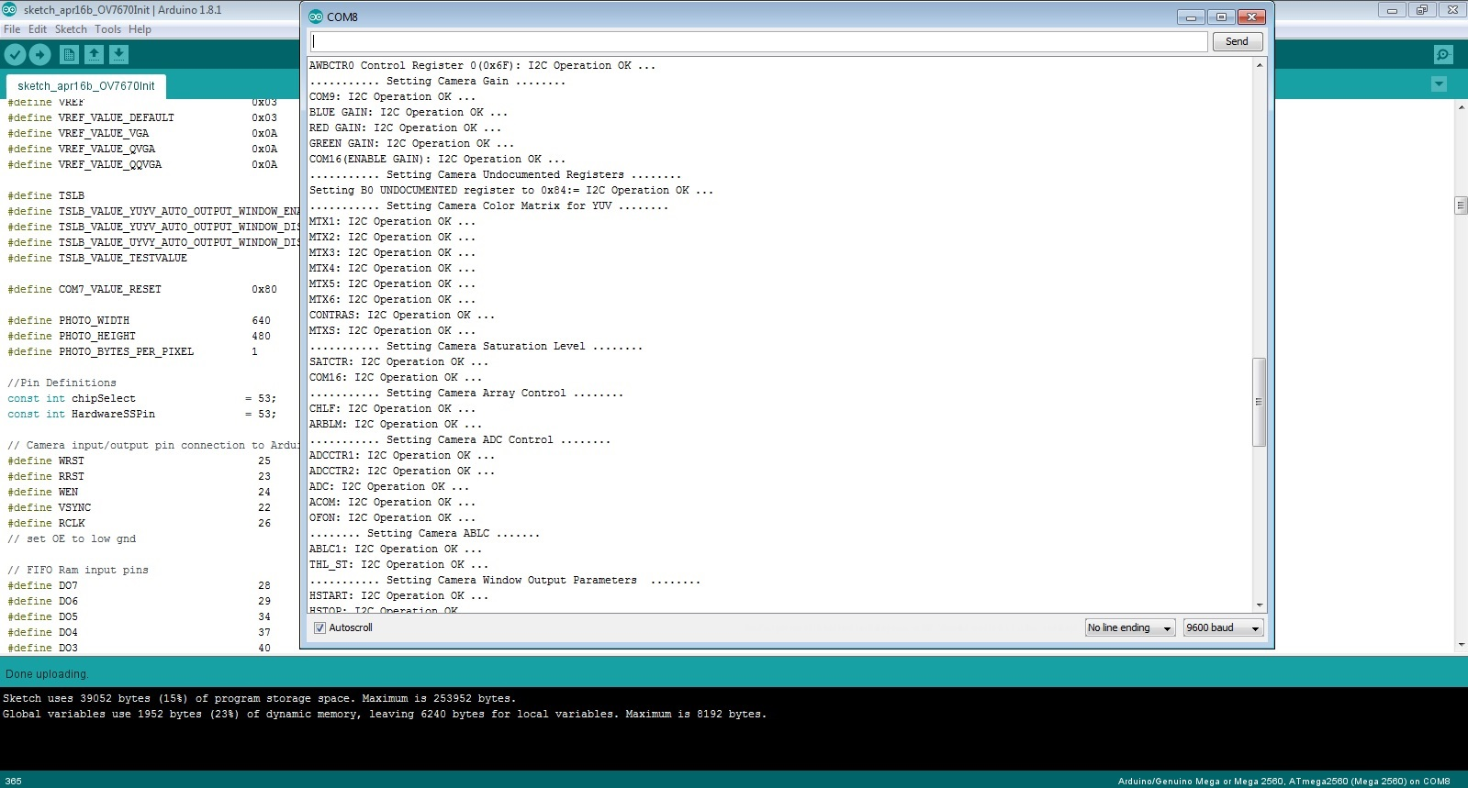

Starting the Image CAPTURE,

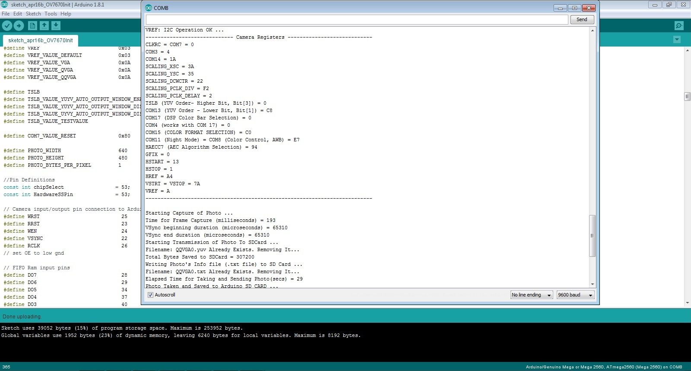

Part 2:

In this part we start with the Hardware discussion of SD Card Reader that

we have interfaced with the Arduino to save the Image captured by the Camera.

We start with SD Card Reader Input/Output pins and an overview of the

SD Card itself. The SD Card Reader Input and Output Pins are shown in

the fig. below:

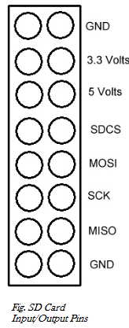

The SDCS is the SD Card's Chip Select Pin. This is the Pin the master can use to enable/disable specific devices. When the device's Chip Select is LOW, it communicates with the Master. When it is HIGH, it ignores the Master. This allows to have multiple devices sharing the same MISO, MOSI and CLK lines. The MOSI, Master Out, Slave In is the Master Line for sending Data to the peripherals. The SCK, Serial Clock, the clock pulses which  synchronizes Data transmission generated by the Master. The MISO, Master In, Slave out, the Slave line for sending data to the Master.

In terms of connecting the SD Card to the Arduino Mega, this is done by

> Connecting Pin 50 on the Arduino to the (MISO)Pin on the SD Card.

> Connecting Pin 51 on the Arduino to the (MOSI)Pin on the SD Card.

> Connecting Pin 52 on the Arduino to the (SCK)Pin on the SD Card.

> Connecting Pin 53 on the Arduino to the (SDCS)Pin on the SD Card.

Apart from it, connect the GND Pin of the SD Card to the GND of Arduino & 5V of the Arduino header to 5V Pin of the SD Card.

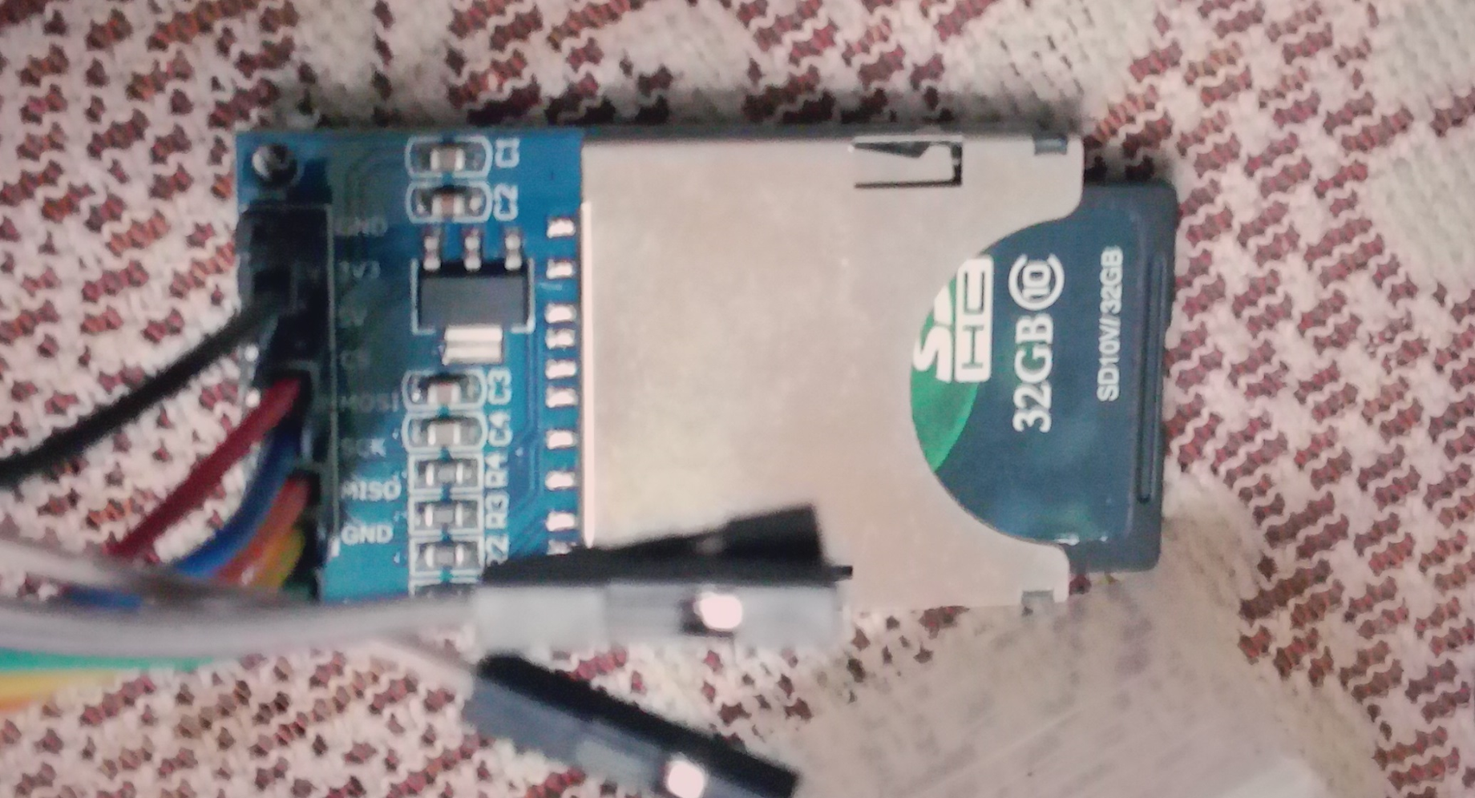

The Arduino comes with a built in library of functions that allow to access to the SD Card. There are functions that allow the user to WRITE Data to the SD Card, READ Data from the SD Card, check if a file on the SD Card exists, and Delete a File from the SD Card.

In order to use the SD Library functions we need to include the SD Library Header in your source code such as:

#include <SD.h>

The Hardware Slave select Pin would be user defined and we have selected a free Pin,which is not being used as some other MUX Functions, like UART, SPI, PWM et al.

This is an important point to take care of.  The User defined Pins should be selected in such a away that it is not getting used for some other functionality. We have selected it as Pin 53.

const int HardwareSSPin = 53;  // For Arduino Mega

Also, we will set the HardwareSSPin as an Output type, in order for the SD Card Library to work.

pinMode(HardwareSSPin, OUTPUT);

We begin the Initialize by, the following code:

      if (!SD.begin(chipSelect))

      {

        Serial.println(F("Initialization failed ... /nThings to check:"));

        Serial.println(F("- Is a card is inserted?"));

        Serial.println(F("- Is your wiring correct?"));

        Serial.println(F("- Did you change the chipSelect pin to match your shield or module?"));

        return;

      } else {

         Serial.println(F("Wiring is correct and a card is present ..."));

      }

Now, we define the chipSelect Pin as 48, we could have defined any other Digital Pin also as chipSelect,

const int chipSelect = 48;

If the Initialization succeeds, a TRUE is returned, otherwise a FALSE would be returned. In order to READ/WRITE a File to the SD Card, we declare a variable of type FILE, call SD.open() function with parameters for the file name and the parameter "FILE_WRITE"or "FILE_READ", to create a file for Reading & Writing or for Reading only. If the return value from SD.open() function is null or 0, then there was an error opening the file, otherwise the File object is valid.

Once, we have a valid file object, we can WRITE data to it by calling print() function to Write text data or write()  function to Write binary data. We can READ data from the file, by calling read() function which can be looped inside the available() function, which checks if there are further bytes to be READ.

This completes SD Card section of the project.

Part 3:

Furthermore, here are the Pin interfacing connections between the SD Card & Arduino Mega.

// On the Arduino Mega, this is

// 50 (MISO)

// 51 (MOSI)

// 52 (SCK)

// 53 (SS)

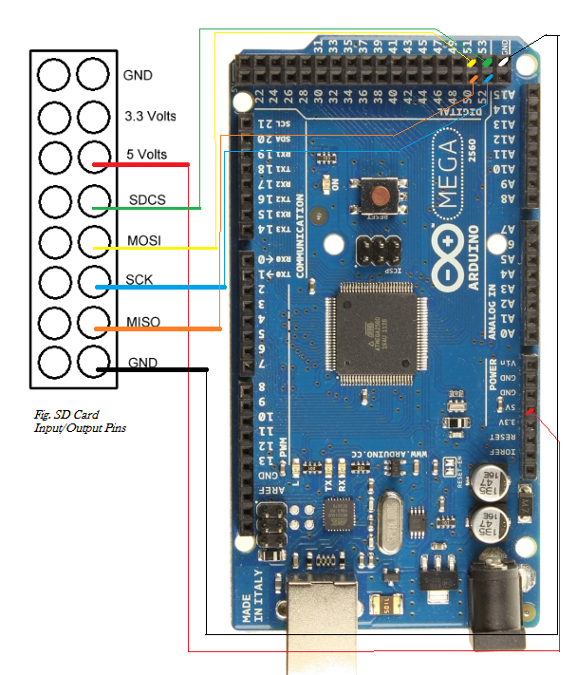

Interfacing connections between Arduino Mega & the SD Card Module.

Between the Camera & Arduino Mega, below are the Interfacing schematics,

// Camera input/output pin connection to Arduino

#define WRST                           25      // Output Write Pointer Reset

#define RRST                           23      // Output Read Pointer Reset

#define WEN                            24      // Output Write Enable

#define VSYNC                          22      // Input Vertical Sync marking frame capture

#define RCLK                           26      // Output FIFO buffer output clock

// FIFO Ram input pins

#define DO7                            28

#define DO6                            29

#define DO5                            34

#define DO4                            37

#define DO3                            40

#define DO2                            43

#define DO1                            48

#define DO0                            49

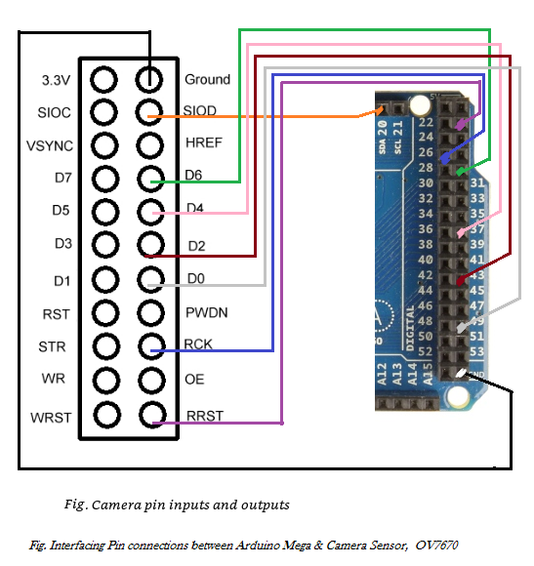

& the below next schematic completes the same, of the interfacing connections between the Arduino Mega & the Camera sensor,

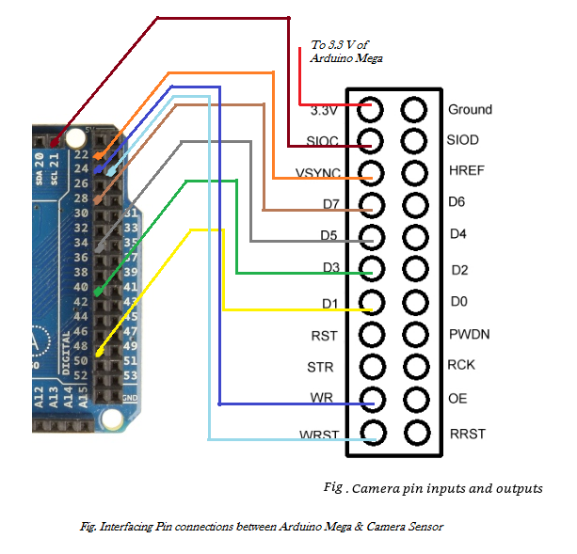

The Image captured by OV7670 will be in YUV or RAW Format for VGAP/VGA(Raw Bayer or Processed VGA)(640x480), QVGA(320x240), QQVGA(160x120) Resolution.

Have used FFMPEG Commands to convert them into PNG format.

FOR VGA/VGAP FORMAT:

ffmpeg -f rawvideo -s 640x480 -pix_fmt bayer_bggr8 -i VGA01.RAW -f image2 -vcodec png OUTFILEP01.png

FOR QVGA/QQVGA FORMAT:

ffmpeg -f rawvideo -s 320x240 -pix_fmt yuv422 -i QVGA1.YUV -f image2 -vcodec png OUTFILE1.png

This completes our little project & we say goodbye.